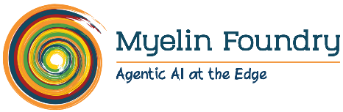

PRODUCT ENGINEER - AI

Myelin is revolutionizing the future of automotive and entertainment experiences through multi-modal edge AI solutions. We are a dynamic team committed to driving transformation through technology and are seeking passionate individuals to join us in our journey.

We are looking for smart, passionate engineers with strong programming skills, strong fundamentals in deep learning (algorithms & frameworks), machine learning, image processing and pattern recognition, as well as excellent communication skills. You and other engineers in this team will help advance Myelin Foundry's capacity to build and deploy leading solutions.

Mandatory Skills
- Strong foundations in deep-Learning based object detection, image analysis, audio analysis, image segmentation (CNN, Autoencoders, GANs, RNNs)
- Experience with Fast.ai/TensorFlow /Torch/Keras or similar deep learning framework
- Strong fundamentals in image processing and computer vision, statistics and machine learning
- Excellent analytical, logical and problem-solving skills
- Proven coding and project development background
- Excellent verbal & written communication skills

Preferred Skills
- Experience in image processing tools such as Matlab, OpenCV
- Programming experience with Python and one or more of C++/Java
- Exposure to statistical techniques

Experience
B.Tech Degree with 1-3 years’ experience in Machine Learning/AI

Contact:
HR Team
careers@myelinfoundry.com www.myelinfoundry.com

